**Module-3 JAVA RDBMS & Database Programming with JDBC**

1.Select unique job from EMP table.

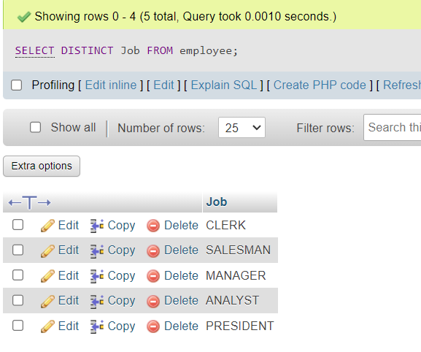

1. List the details of the emps in asc order of the Dptnos and desc of Jobs?

**Deptno in Asc**

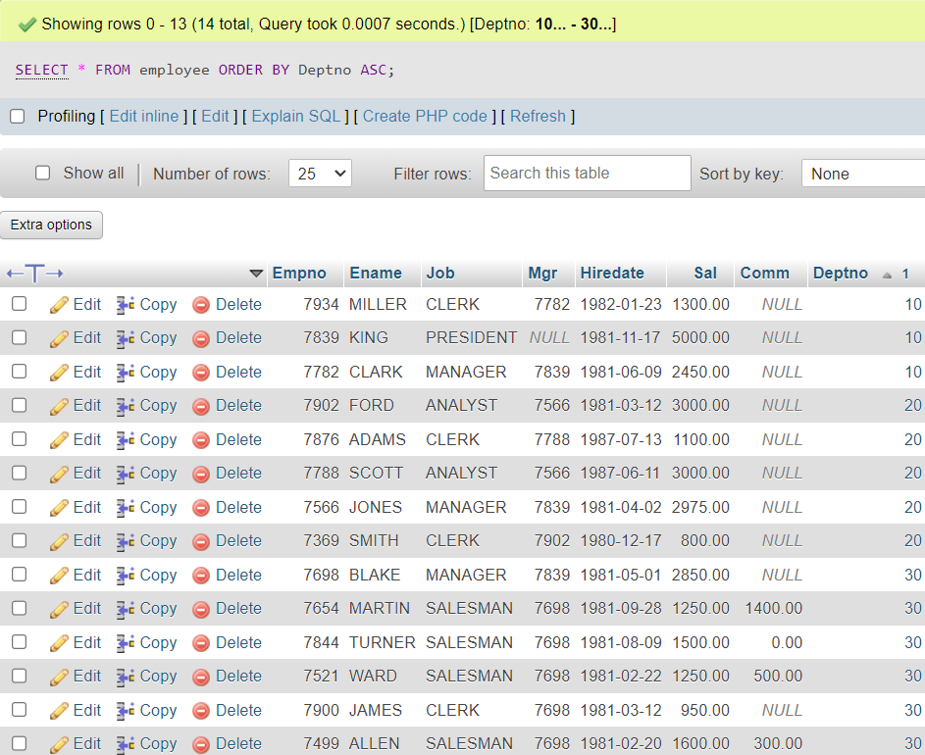

Jobs Sorting in DESC

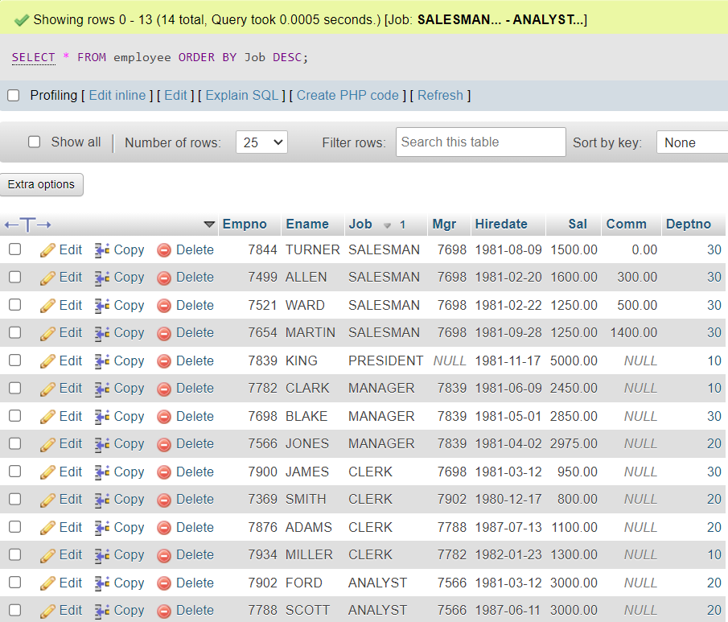

1. Display all the unique job groups in the descending order?



1. List the emps who joined before 1981.

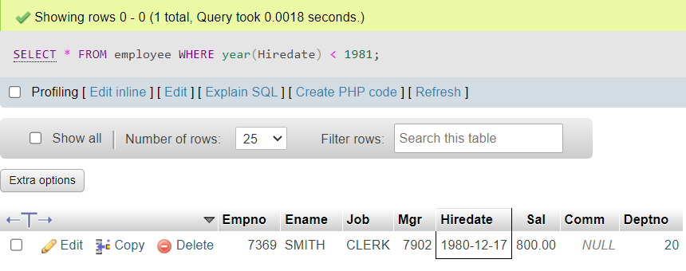

1. List the Empno, Ename, Sal, Daily sal of all emps in the asc order of Annsal.

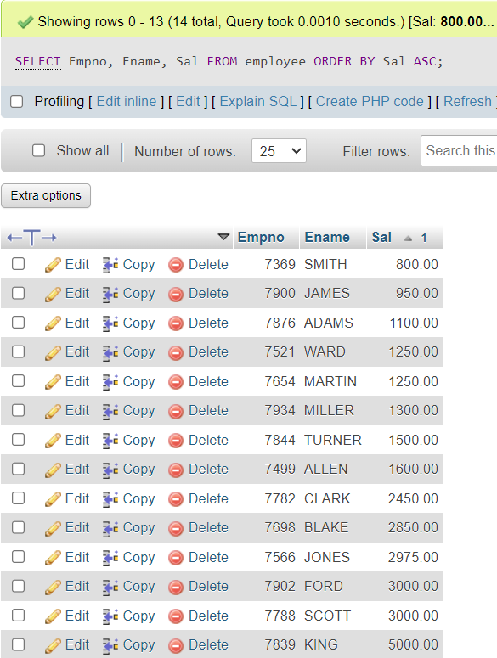

1. List the Empno, Ename, Sal, Exp of all emps working for Mgr 7369.

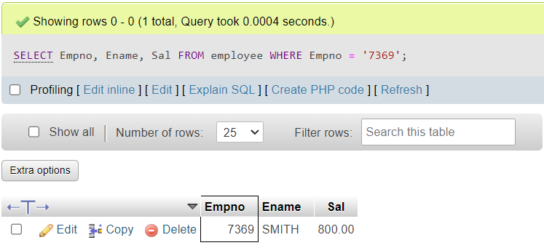

1. Display all the details of the emps who’s Comm. Is more than their Sal?

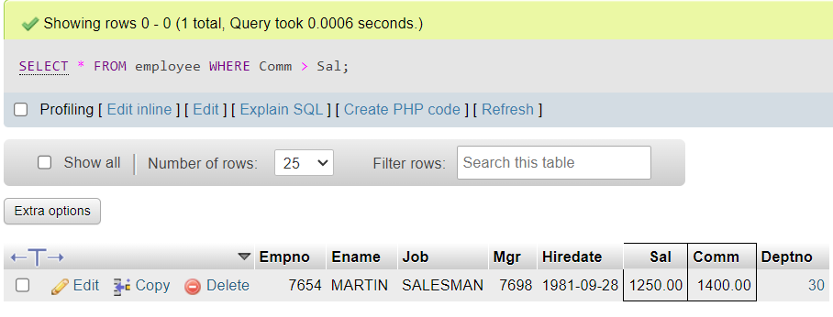

1. List the emps who are either ‘CLERK’ or ‘ANALYST’ in the Desc order.

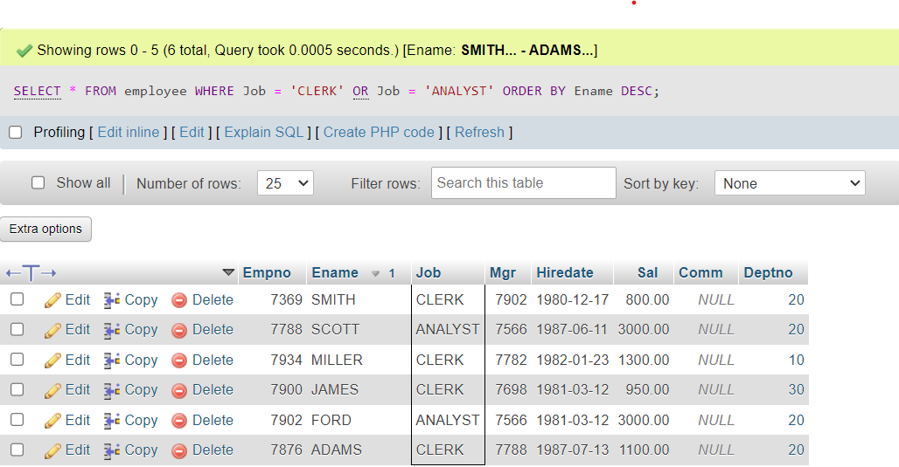

9.List the emps Who Annual sal ranging from 22000 and 45000

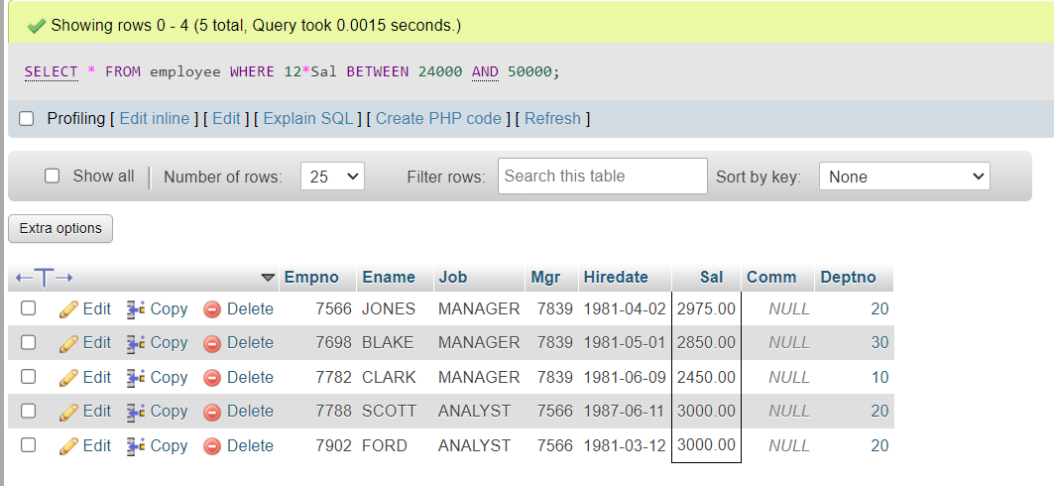

10.List the Enames those are starting with ‘S’ and with five characters.

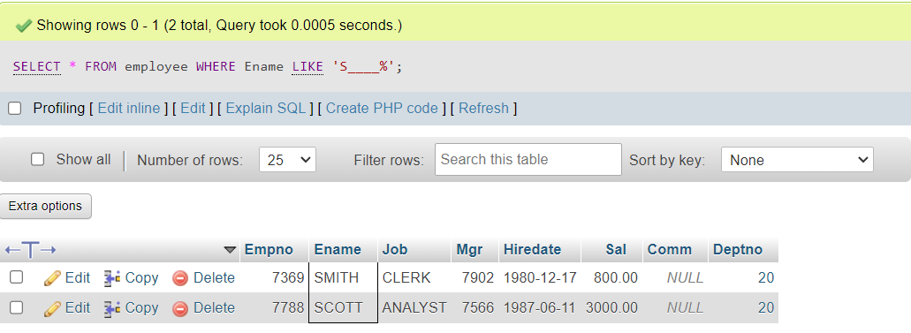

11.List the emps whose Empno not starting with digit78.

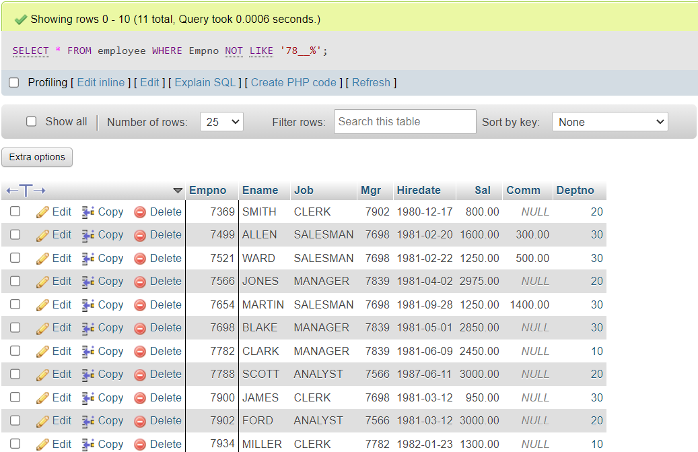

12.List all the Clerks of Deptno 20

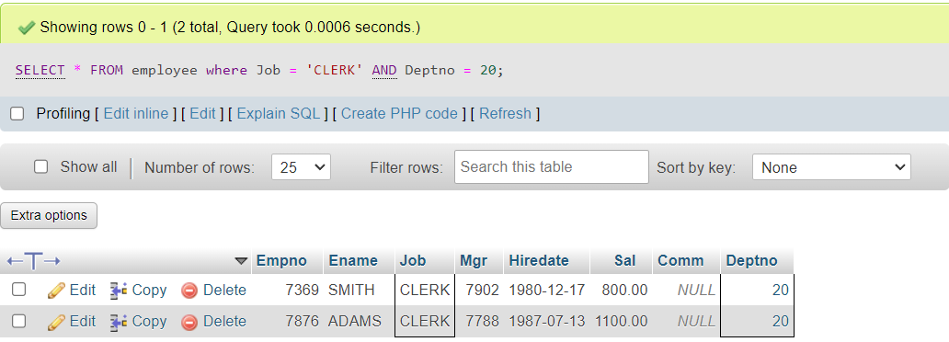

13.List the Emps who are senior to their own MGRS.



14.List the Emps of Deptno 20 who’s Jobs are same as Deptno10

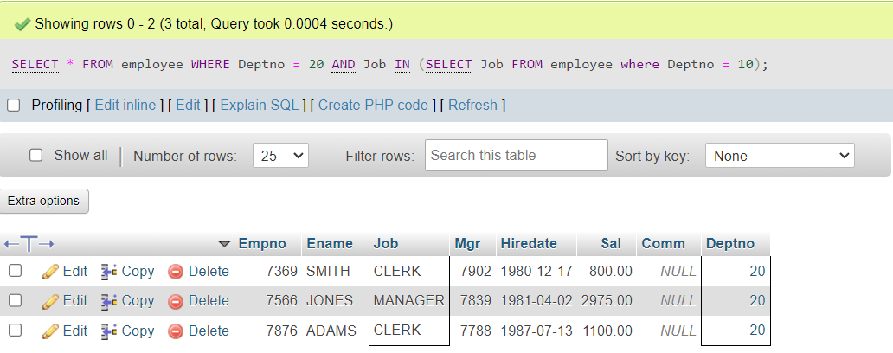

15.List the Emps who’s Sal is same as FORD or SMITH in desc order of Sal

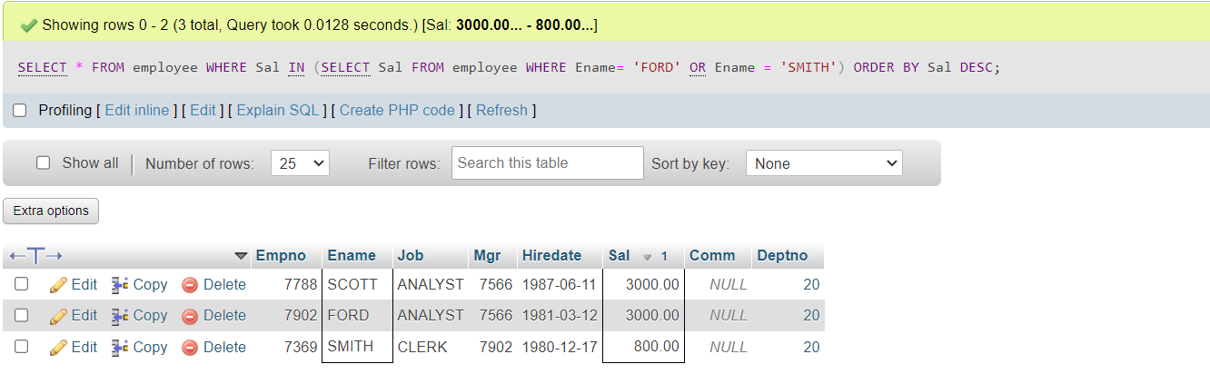

16.List the emps whose jobs same as SMITH or ALLEN.

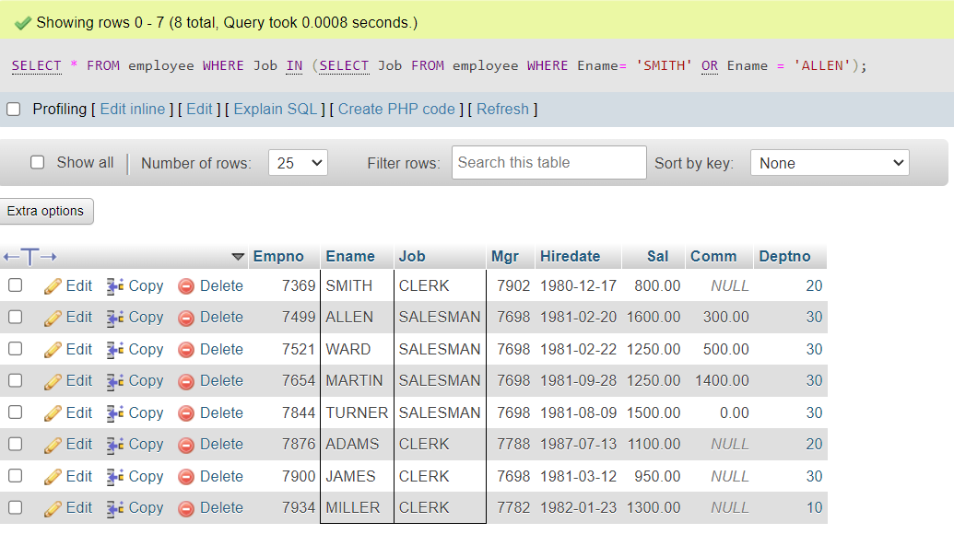

17.Any jobs of deptno 10 those that are not found in deptno 20.

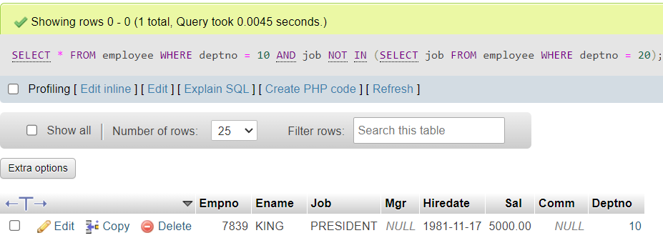

18.Find the highest sal of EMP table.

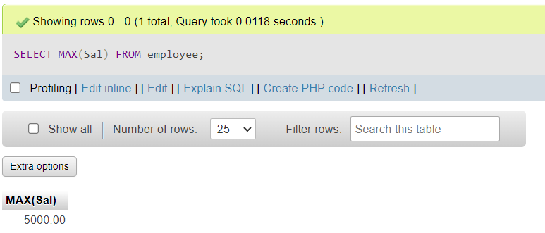

19.Find details of highest paid employee

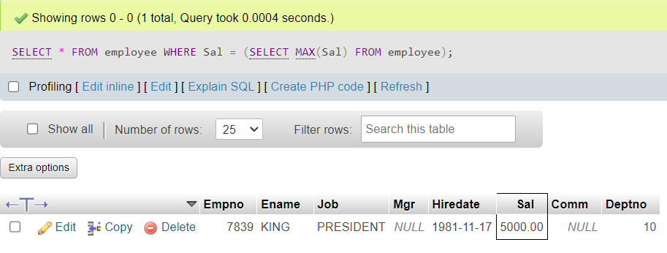

20.Find the total sal given to the MGR

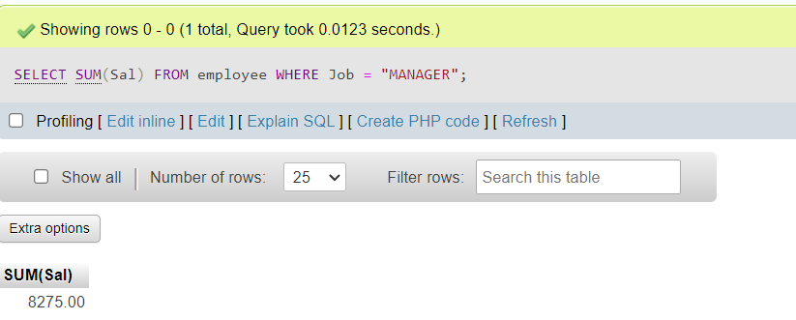

1. List the emps whose names contains ‘A’

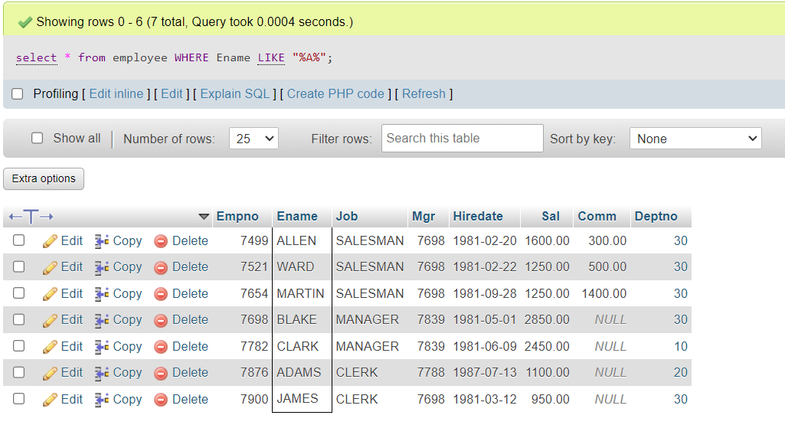

1. Find all the emps who earn the minimum Salary for each job wise in ascending order

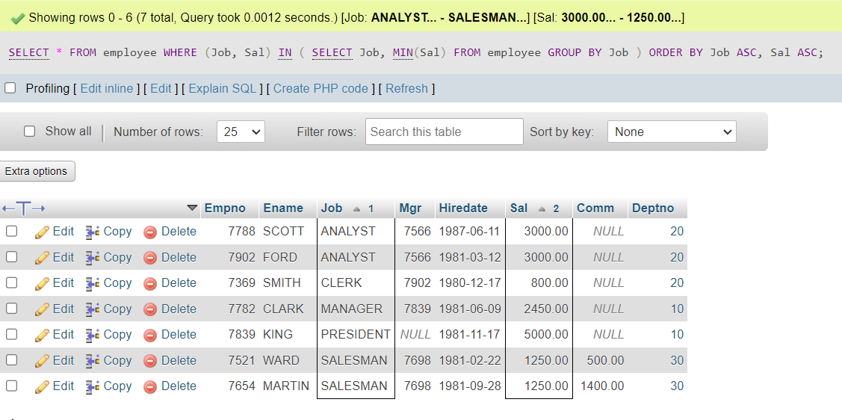

1. List the emps whose sal greater than Blake’s sal.

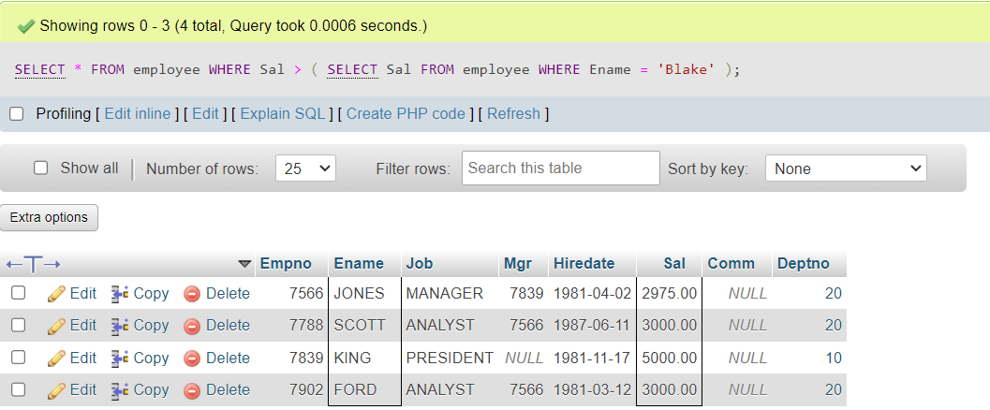

24. Create view v1 to select ename, job, dname, loc whose deptno are same

Ans.) CREATE VIEW v1 AS SELECT e.Ename, e.job, d.Dname, d.Loc

FROM employee e

JOIN dept_table d ON e.Deptno = d.Deptno;

25.Create a procedure with dno as input parameter to fetch ename and dname.

Ans.) DELIMITER //

CREATE PROCEDURE GetEmployeeAndDepartment(IN dno INT)

BEGIN

SELECT Ename, Dname

FROM employee

JOIN dept_table ON employee.Deptno = dept_table.Deptno

WHERE employee.Deptno = dno;

END //

DELIMITER ;

1. Add column Pin with bigint data type in table student

Ans.) ALTER TABLE student ADD COLUMN Pin BIGINT;

1. Modify the student table to change the sname length from 14 to 40.Create trigger to insert data in emp_log table whenever any update of sal in EMP table. You can set action as ‘New Salary’.

Ans.) ALTER TABLE student MODIFY Sname VARCHAR(40);